Day 6: Attack Surface Mapping
Course: Ethical Hacking
University: AWKUM
Date: 16-Sep-2026
Submitted by: Urooj Atif

## 1. Target Information
- **Target Name**: Abdul Wali Khan University Mardan
- **Target URL**: https://awkum.edu.pk
- **Scope**: Public facing website and sub-services

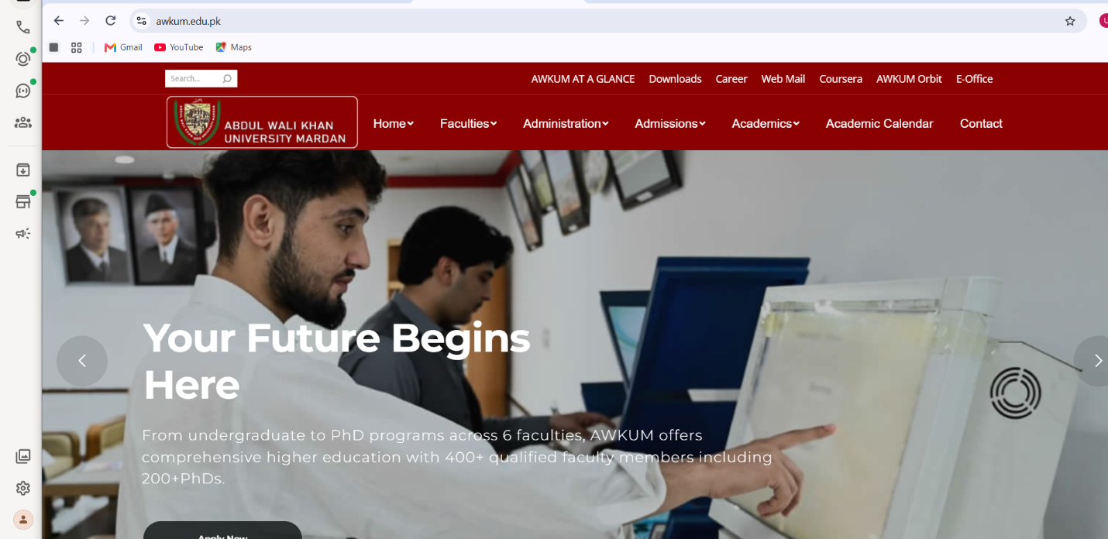

## 2. Pages Identified
After scanning the homepage, we identified these pages:

| Page Name | URL | Notes |
| --- | --- | --- |
| Home | / | Main Landing Page |
| Faculties | /faculties | Departments List |
| Admissions | /admissions | Admission Information |
| Administration | /administration | Admin Section |
| Academics | /academics | Academic Programs |
| Contact | /contact | Contact Information |
| Web Mail | /webmail | Authentication Required - Login Portal |
| E-Office | /eoffice | Authentication Required - Staff Portal |

## 3. Endpoints & Parameters

From Network tab analysis, we found these endpoints:

| Endpoint | Method | Parameters Found | Purpose |
| --- | --- | --- | --- |
| /page.php | GET | href=https://... | Main Page Content Loading |
| /embed | GET | pb=1m14!1m8!1m3!1... | Google Maps Embed API |
| /01.jpg | GET | - | Homepage Banner Image |
| /track | GET | dtry9swzghlkpxyzh | Google Analytics Tracking |
| Google Fonts API | GET | family=Roboto | External Font Resource |
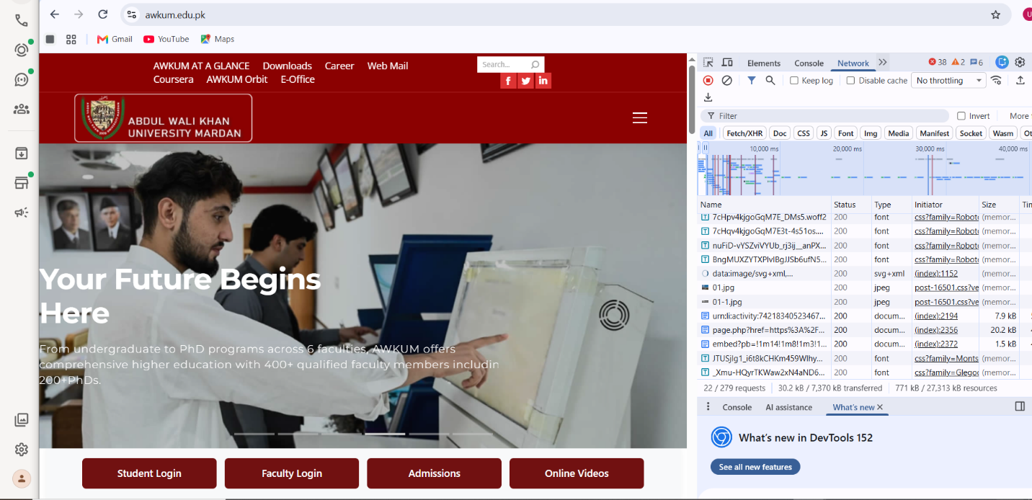

## 4. Authentication Areas
We found 2 Login Portals in the Attack Surface:

1. **Web Mail**: /webmail
2. **E-Office**: /eoffice

Both areas require authentication.

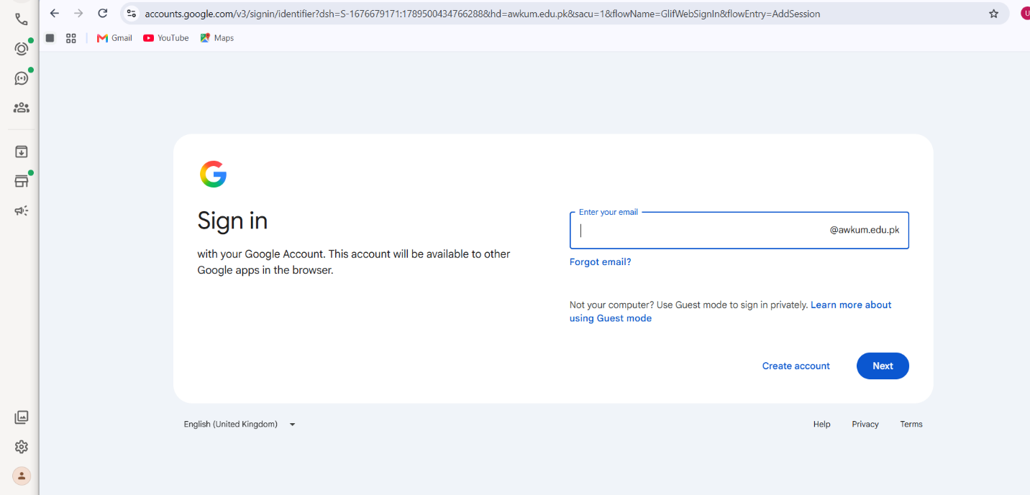
## 5. Technology Stack Identified
After website analysis we identified:

- **CMS**: WordPress
- **Framework**: Custom CSS v2.5.0.1
- **External Services**: Google Analytics, Google Maps, Google Fonts
- **Server Type**: Apache

## 6. Conclusion
The Attack Surface of AWKUM website has been mapped. Total 8 main pages and 5 key endpoints were identified. 2 authentication areas were also found: Web Mail and E-Office. The next step will be vulnerability testing on these endpoints.

